PTC Meeting 5/14/20 7pm, via Zoom
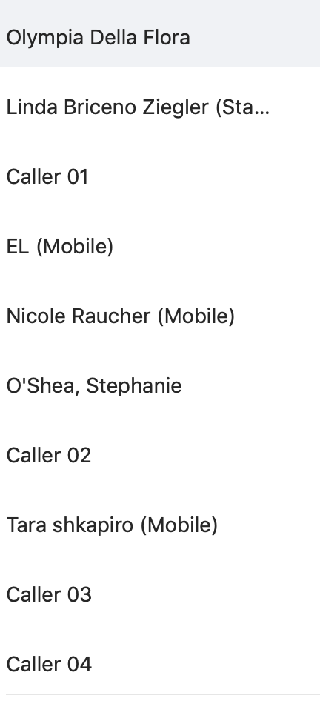


Attendees



Additionally, those who wrote in:

Marni Amsellem
Camille Quatracchi
Lynn Huse ?

Presentation of Educational Plan by Assoc Superintendents (details on slides)

Phase 1
distribution of hotspots/ chromebooks, food
implemented March 12/13

Phase 2 Distance Learning

Phase 3 Summer

Phase 4 Looking ahead to the fall
- multiple considerations such as class size, food, infection control
- re-entry/ re-establish routine

Farewell from outgoing president. Thank you to Michelle Lesser

Announcements:

- PT Council will meet this summer each month
- Task force re: schools opening in the Fall will be meeting
- Send ideas regarding 2020 graduations to Tamu. Sharon Beadle
- $15 mil budget cut to schools due to economic challenges from COVID-19
- PTO presidents need to send paperwork
- Presidents meetings will be next week (separate for elementary and middle/ high schools)
- Open PTC position- First VP (outgoing VP has offered to advise)
- questions:
    - allocation of $
    - virtual field trip ideas?
    - many PTOs are struggling to fill open board positions- how to solve this problem

